LEAD Program at UM-Rolla – http://campus.umr.edu/lead

The Learning Enhancement Across Disciplines Program provides learning forums for students who wish to improve their understanding of concepts and their mastery of skills in a wide variety of foundational courses:
• faculty-based Learning Centers for specific courses (in department building)
• drop-in peer tutoring for ~25 foundational courses (in Student Learning Center)
The LEAD program hires and trains accomplished undergraduates to assist in these venues.

Learning Centers (in department buildings)

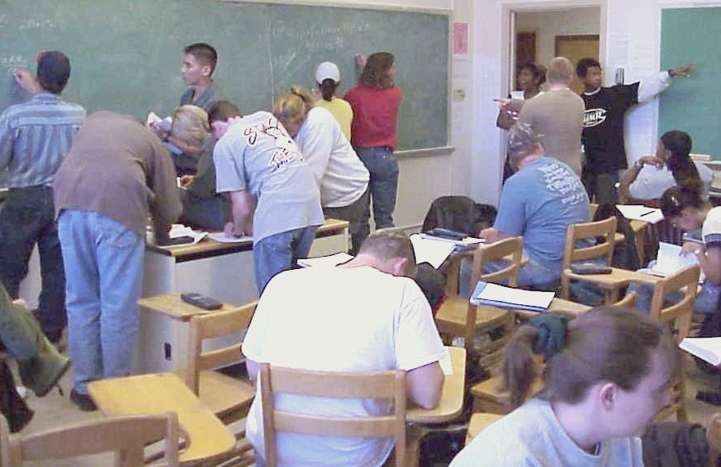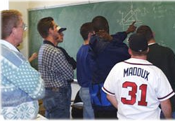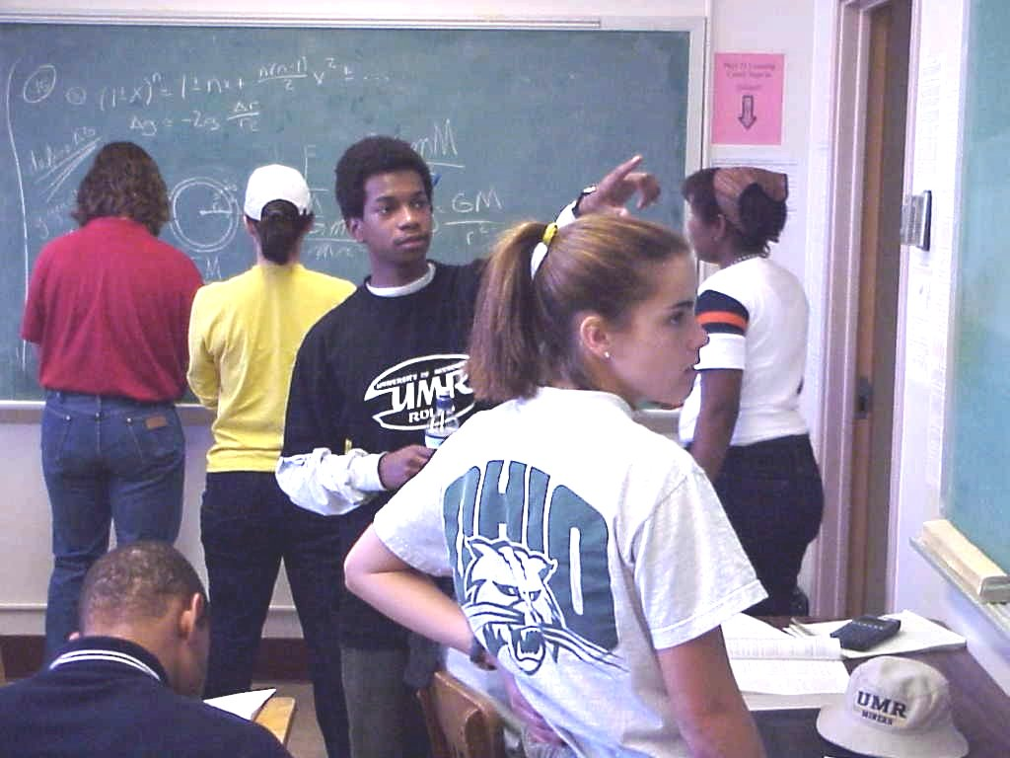

• Staffed by discipline-based faculty (in lieu of office hours) and trained peer instructors
• Cooperative/collaborative problem-based learning among students
• Promotion of camaraderie, teamwork and leadership (including personal responsibility)
• Direct interaction with faculty for content material and various role model attributes
• Confidence building through actual personal proficiency in a course's material

Advantages
• Complete implementation of Seven Principles of Good Practice
• Lots of students can be handled
• Students come to get HW done in social environment
• Easy for student and faculty to disengage, therefore less threatening
• Student complaints reduced because help readily available – whether used or not
• Student satisfaction (and ratings) increase
• Grade improves with LC attendance
Disadvantages or barriers
• Can be noisy and too active for some students
• Faculty need to employ mechanism(s) that "encourage" students keep up personally with the work to some target level of mastery (decided by faculty and/or students)

The LEAD program can provide faculty with advice and assistance in establishing a successful Learning Center, through consultation with experienced LEAD faculty or printed practical guides (e.g. http://campus.umr.edu/lead/files). Please contact Ronald Bieniek, Director of LEAD (bieniek@umr.edu).

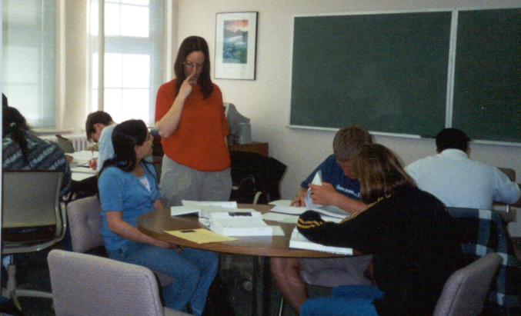
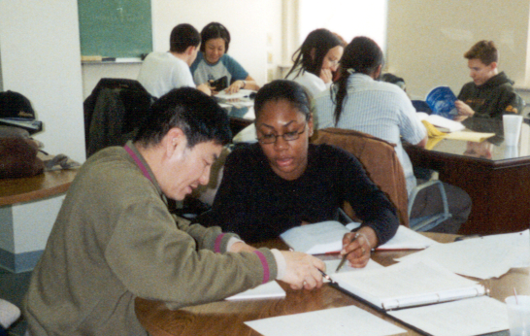
Peer Tutoring (at scheduled times in Student Learning Center, 204 Norwood)

• Tutoring done by accomplished undergraduates who receive pedagogical training
• Focuses on individual and small-group interactive assistance
• Offered in foundational courses from chemistry to foreign languages
• Over a 1000 hours of tutoring per semester

Advantages
• Quiet, calm environment
• Focused personal attention by trained accomplished undergrad peers

Disadvantages or barriers
• No interaction with faculty
• Low level of camaraderie, socialization
• Only a relatively few students are helped

